1. Project Scope
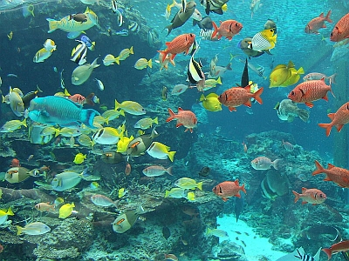  Requirements document for an information system development project | Members  Tiago Martins 52052532 Zoe Claassens 50959042 Knowledge Tshabalala 55456367 Ruby Nyabvure 49948989 Lihle Tshona 51748584 Thokozani Mahlangu 50833464 Arnold Photsane 39156222

This is the updated project scope which aligns with the first scope defined in Phase 1 and Phase 2. The system will also provide a secure and efficient digital solution for managing AquaCore’s Aquarium operations, improving staff coordination, customer service, and marine life management.
• Maintain employee records and staff management
• Maintain user accounts with role-based access control
• Maintain ticket sales and client records
• Maintain visitor attendance and revenue tracking
• Maintain marine life records
• Maintain feeding schedules and medical records for animals
• Maintain animal check-ups and health monitoring
• Maintain restaurant order processing
• Maintain restaurant inventory and stock levels
• Maintain restaurant and ticket revenue tracking
• Maintain transaction records for all departments
• Maintain reporting system for ticket sales, restaurant sales, and overall revenue
• Maintain secure data storage and access control
• Maintain system backup and recovery (cloud/local)
• Maintain simple and user-friendly GUI for staff use

2. Use Case

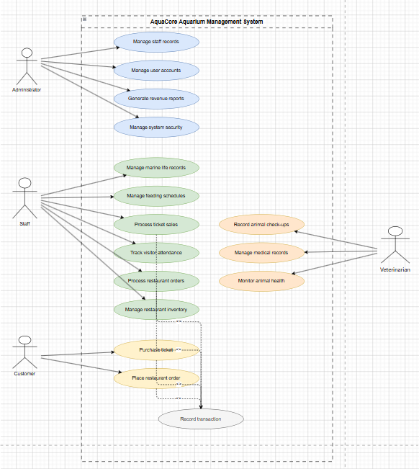

3. Data Models
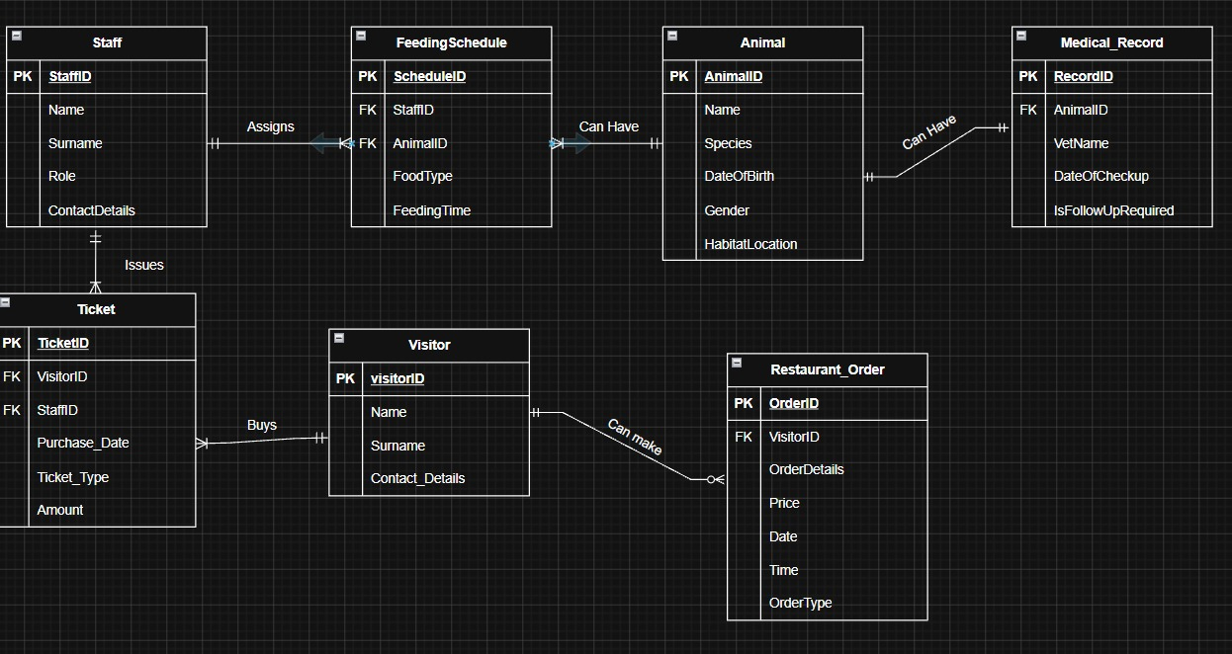

4.

4.Process Model

